🌧️ Indian Rainfall Data Analysis Report

1. Introduction
This project analyzes district-wise daily rainfall measurements across India. The dataset provides granular insights into rainfall distribution, seasonal variations, and regional disparities. The goal is to explore rainfall trends, detect anomalies, and support agricultural and environmental planning through data-driven insights.
2. Dataset Overview
- Source: Indian Rainfall Dataset (district-wise daily records)
- Attributes: Date, District, State, Rainfall (mm), possibly additional metadata (e.g., latitude/longitude).
- Size: Large dataset covering multiple years and districts.
- Target Use: Time-series and spatial analysis of rainfall patterns.
3. Objectives
- Analyze rainfall distribution across districts and states.
- Identify seasonal and annual rainfall trends.
- Detect anomalies and extreme rainfall events.
- Compare rainfall variability across regions.
- Provide actionable insights for agriculture, water resource management, and climate studies.
4. Tools & Libraries
- Python for analysis
- Pandas & NumPy for data cleaning and manipulation
- Matplotlib & Seaborn for visualization
- GeoPandas / Folium for spatial mapping
- Jupyter Notebook for documentation and reproducibility
5. Key Analyses
Exploratory Data Analysis (EDA)
- Distribution of rainfall values across districts.
- Seasonal averages (monsoon vs. non-monsoon months).
- State-wise rainfall comparison.
Outlier Detection
- Identify extreme rainfall events using statistical thresholds (IQR, Z-score).
Visualizations (placeholders for figures)
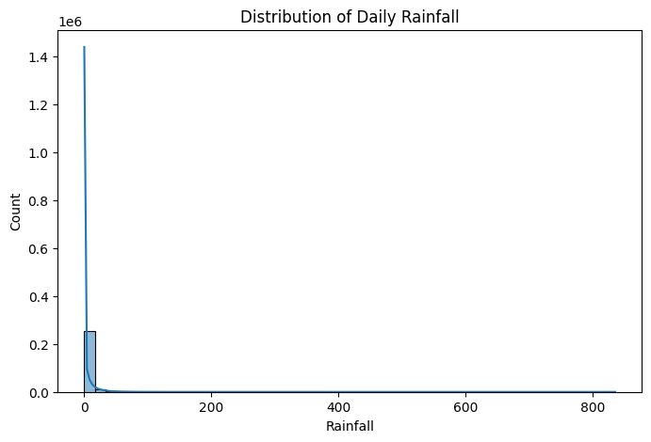
- Histogram: Daily rainfall distribution.

Line Plot: Annual rainfall trend for selected districts.
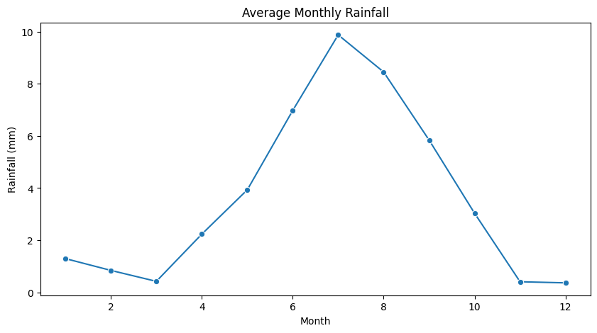

- Heatmap: Correlation between rainfall and seasons.
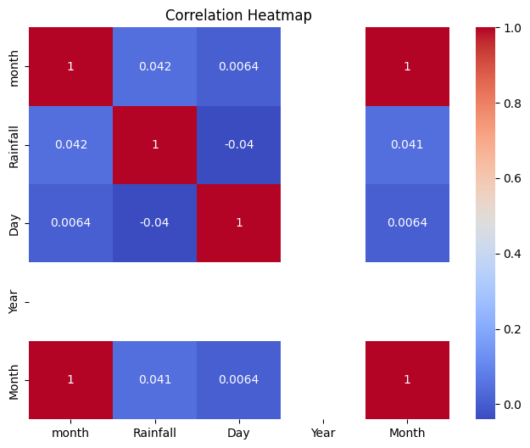
- Geospatial Map: District-wise rainfall intensity.

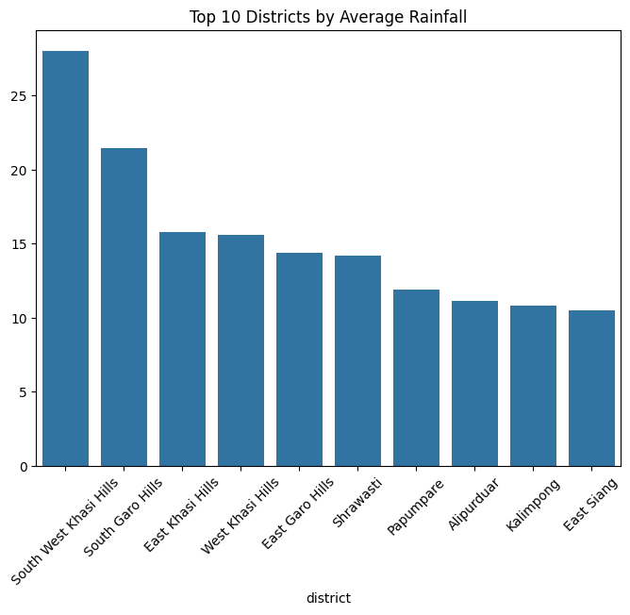
Statistical Analysis
- Hypothesis testing for differences in rainfall between regions.
- Trend analysis using moving averages.
6. Insights
- Monsoon months contribute the majority of rainfall across most districts.
- Certain regions show high variability, indicating vulnerability to droughts or floods.
- Outlier detection highlights extreme rainfall days that may align with flood events.
- State-level comparisons reveal disparities in rainfall distribution, useful for resource allocation.
7. Conclusion
This analysis demonstrates how district-wise rainfall data can be leveraged to understand climate variability and support decision-making in agriculture and water management. By combining statistical methods, visualization, and geospatial analysis, the project provides actionable insights into India’s rainfall patterns.

